CREATING DISTANCE/ TIME GRAPHS

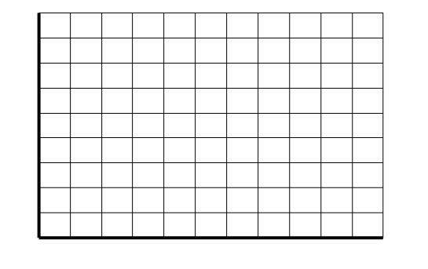
VIDEO #1—MONSTERS INC.
Time ( Seconds)
Distance (Feet)

VIDEO #2—THE INCREDIBLES
Distance (meters)
Time ( Seconds)

