CREATING DISTANCE/ TIME GRAPHS

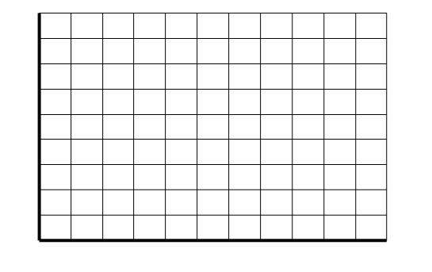
VIDEO #3--SPIDERMAN
Time ( Seconds)

Distance From Ground (Meters)

VIDEO #4—HARRY POTTER
Distance From Ground (Meters)
Time ( Seconds)

